Table of content

- Introduction………………………………………………………..3
- Code screenshots
    - Front-end Code Screenshots
      - Homepage HTML………………………………….4
      - homepage CSS………………………………………6
      - Play with friend HTML……………………….…9
      - Play with computer HTML………………..…..11
      - Play with friend and computer CSS………14
    - Backend Code Screenshots………………………..15
- Project structure………………………………………………….20
- How to run…………………………………………………………..20
- Conclusion……………………………………………………………26

Introduction:
This project is a Tic-Tac-Toe game with a web-based frontend and a Flask-powered backend. Its backend code is written in python language. The game allows two players to take turns marking spaces on a 3×3 grid, following the classic rules of Tic-Tac-Toe. The goal is to align three marks in a row, column, or diagonal before the opponent.

The frontend is developed using HTML, CSS, providing an interactive and visually engaging game experience. The backend, built with Python and Flask, handles game logic, player interactions, and result validation via API endpoints.

This project demonstrates the integration of a web frontend with a API, making it a useful reference for understanding full-stack game development.
This document contains the screenshots of the source code for reference

Code screenshots:
This section contains the code screenshots for the Tic-Tac-Toe game. The project is built using HTML and CSS for the frontend and Python (Flask) for the backend. The following sections provide a structured view of both the frontend and backend code, showcasing how the game is designed and implemented.
Frontend Code Screenshot:
The frontend of this game is developed using HTML and CSS, ensuring a simple yet interactive user interface. It consists of multiple files, including:

- Home Page (HTML & CSS) – The main landing page of the game.

- Play with Friend (HTML & CSS) – The game screen for two players.

- Play with Computer (HTML & CSS) – The game screen for playing against an AI.

Each file contributes to the overall design and functionality of the game, making it visually appealing and user-friendly. Screenshots of the frontend code are provided below.

Homepage HTML:

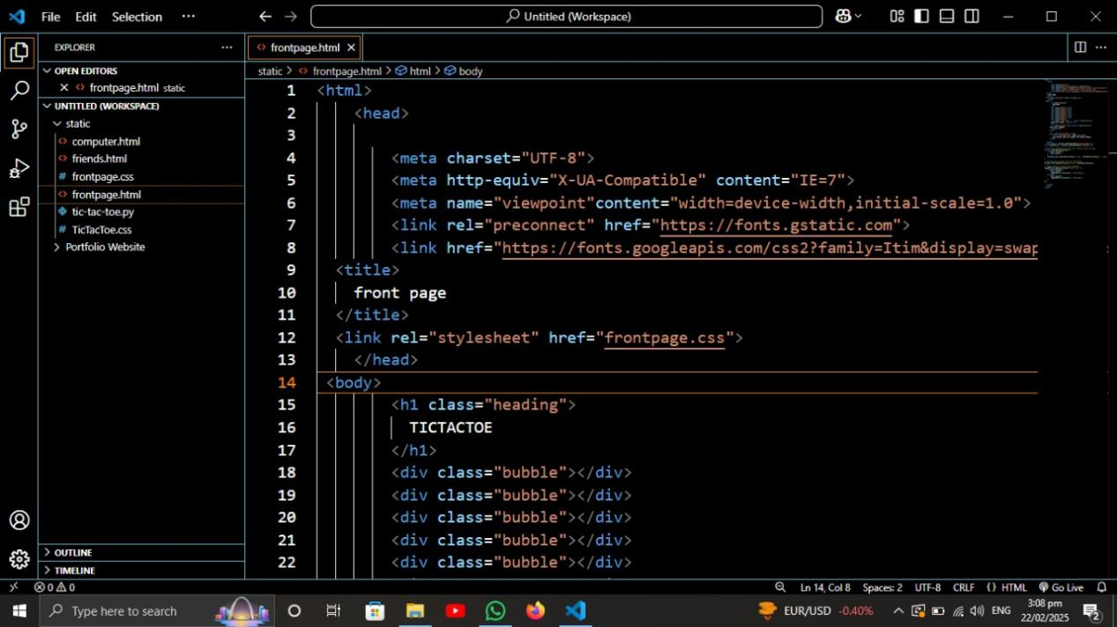

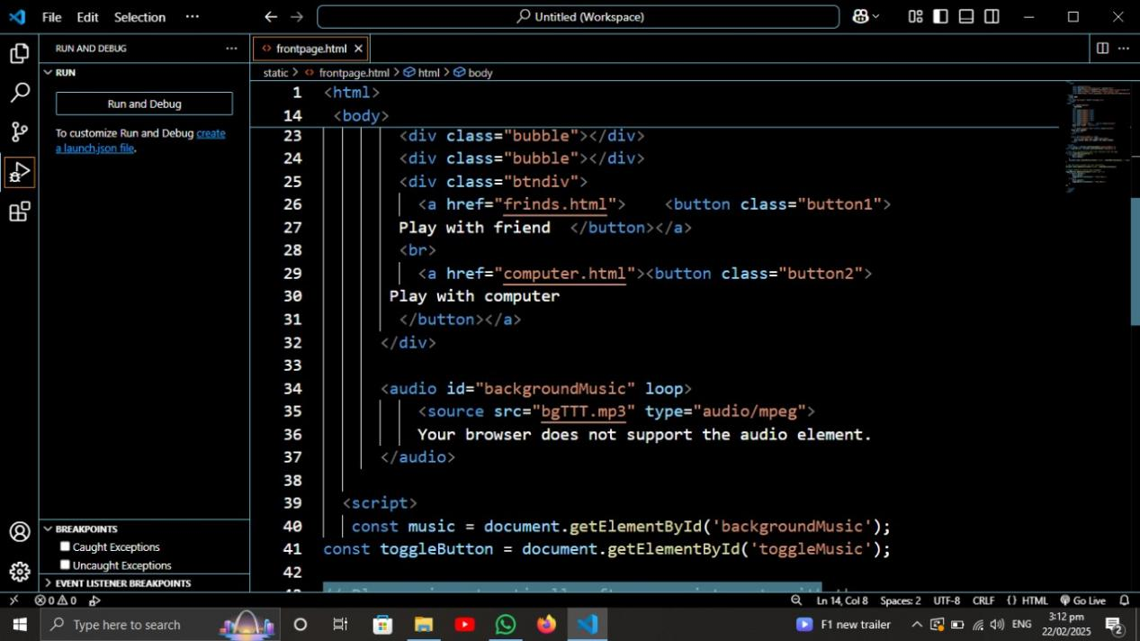

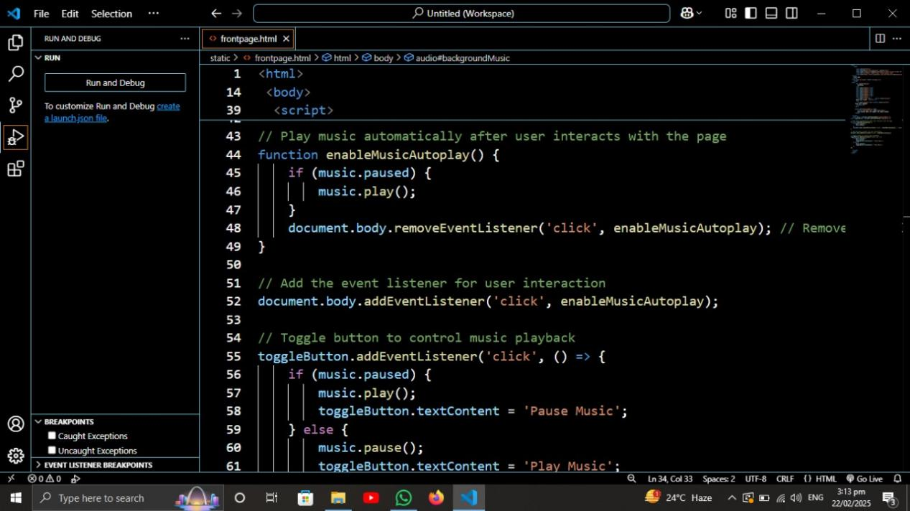

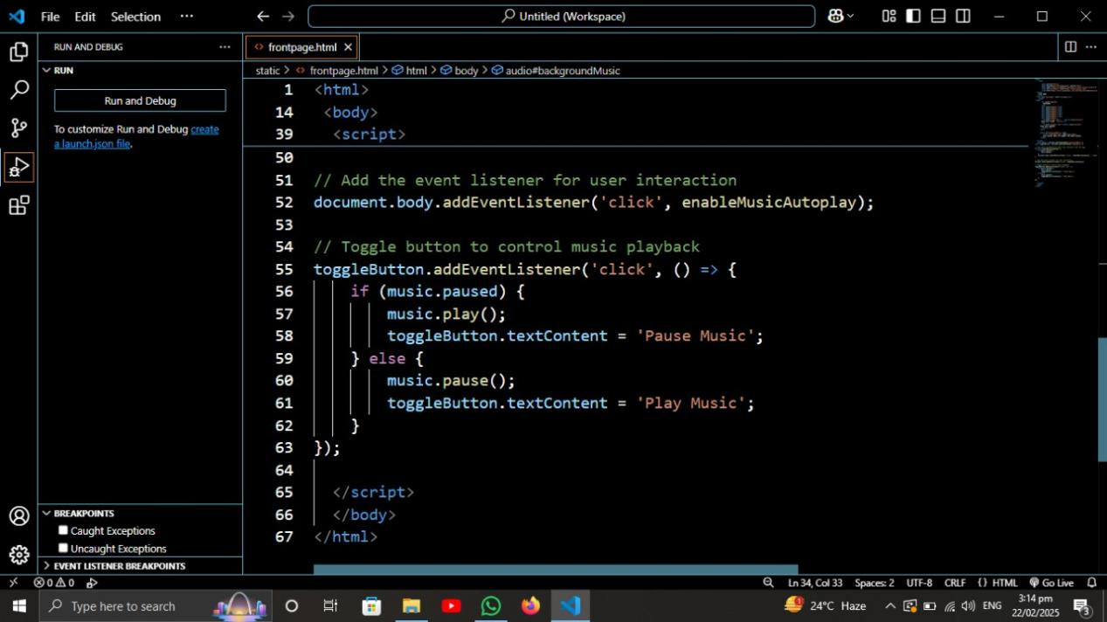

Homepage CSS:

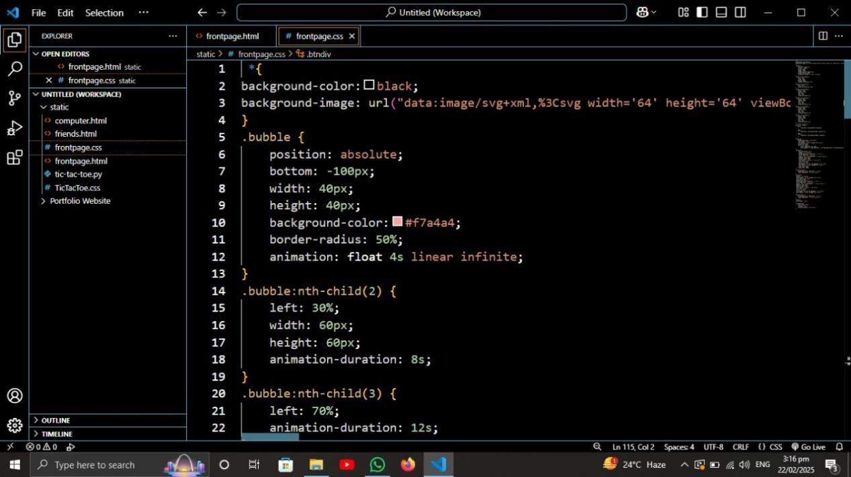

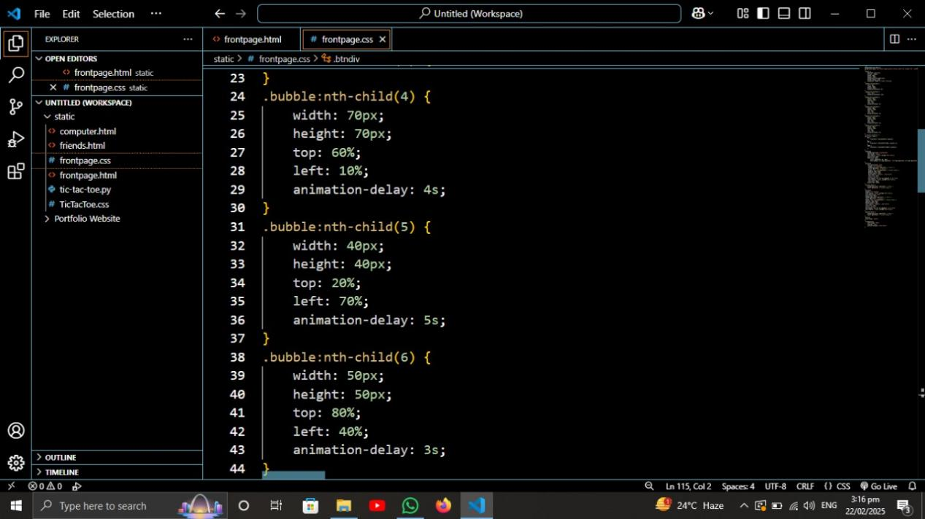

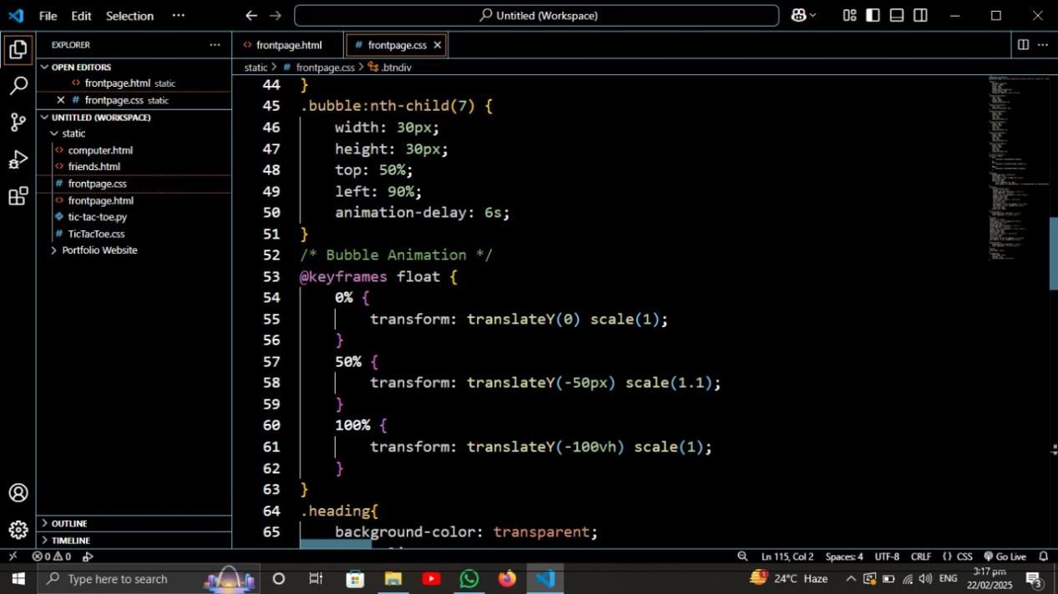

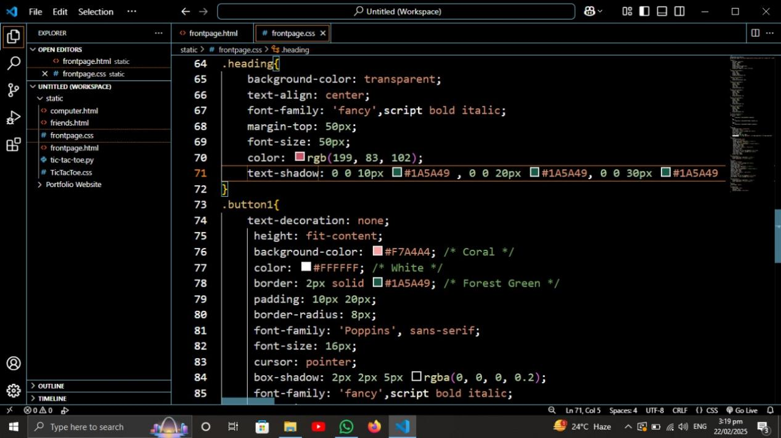

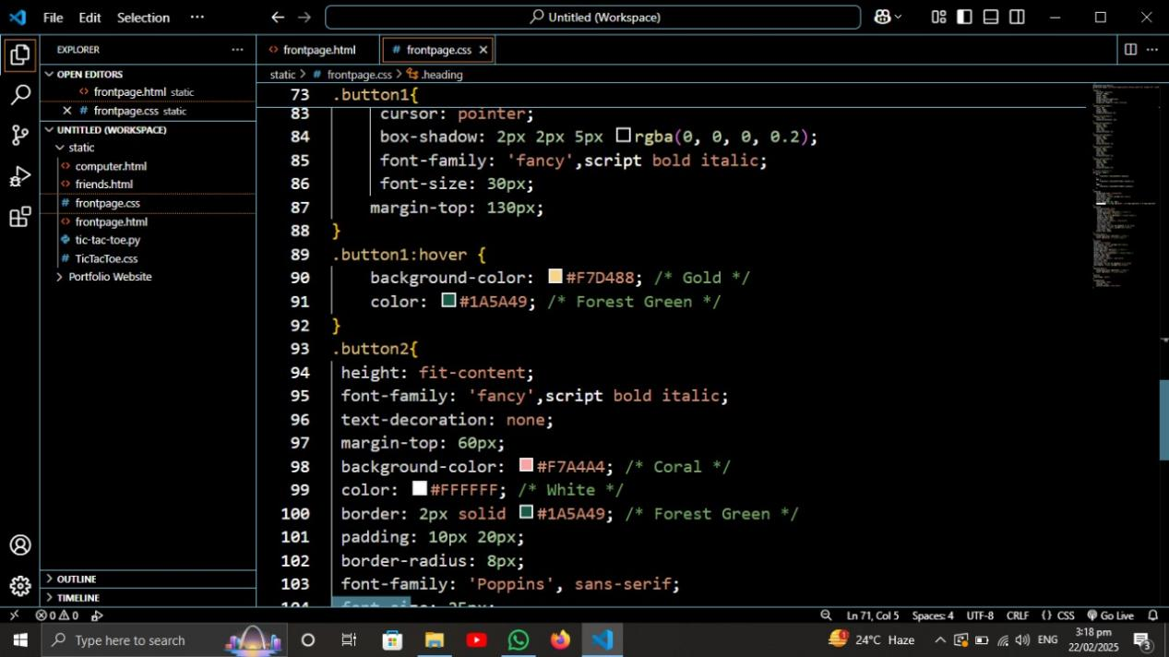

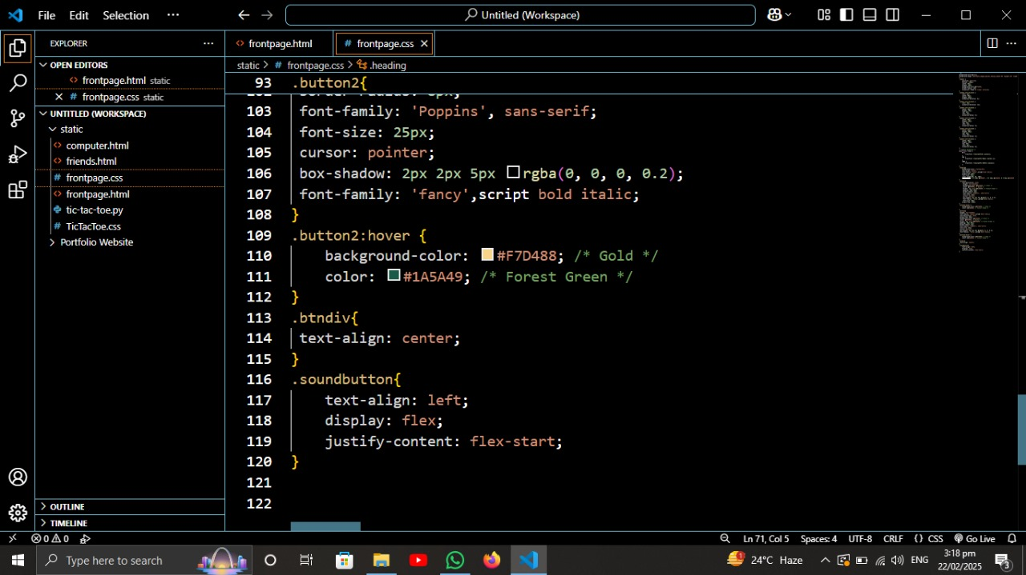

Play with friend HTML:

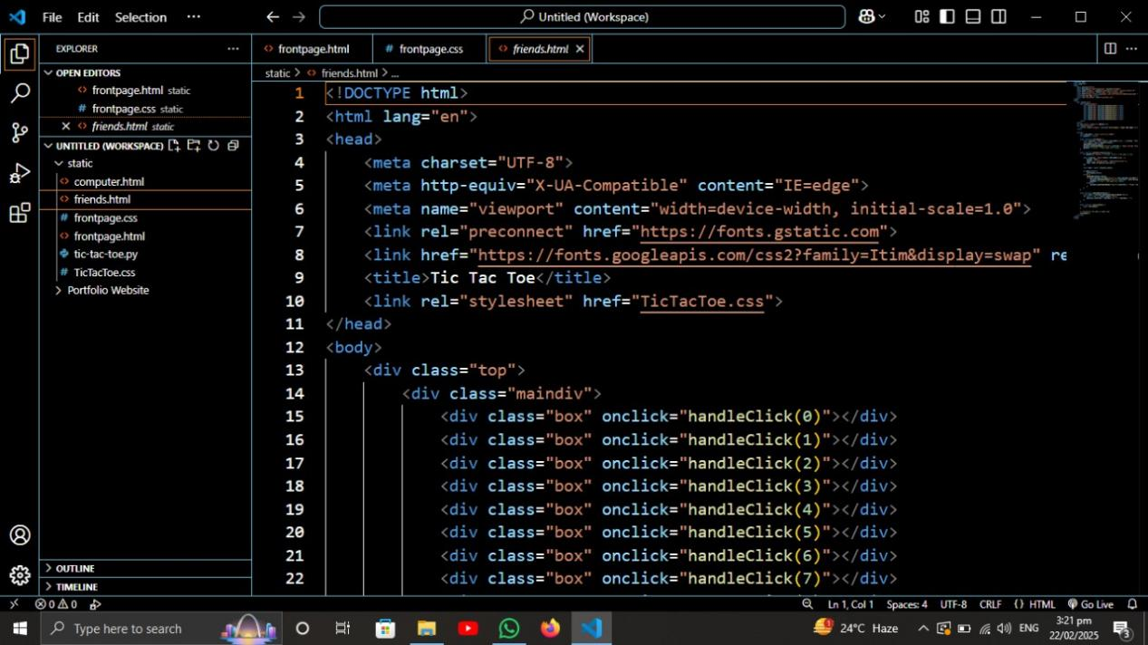

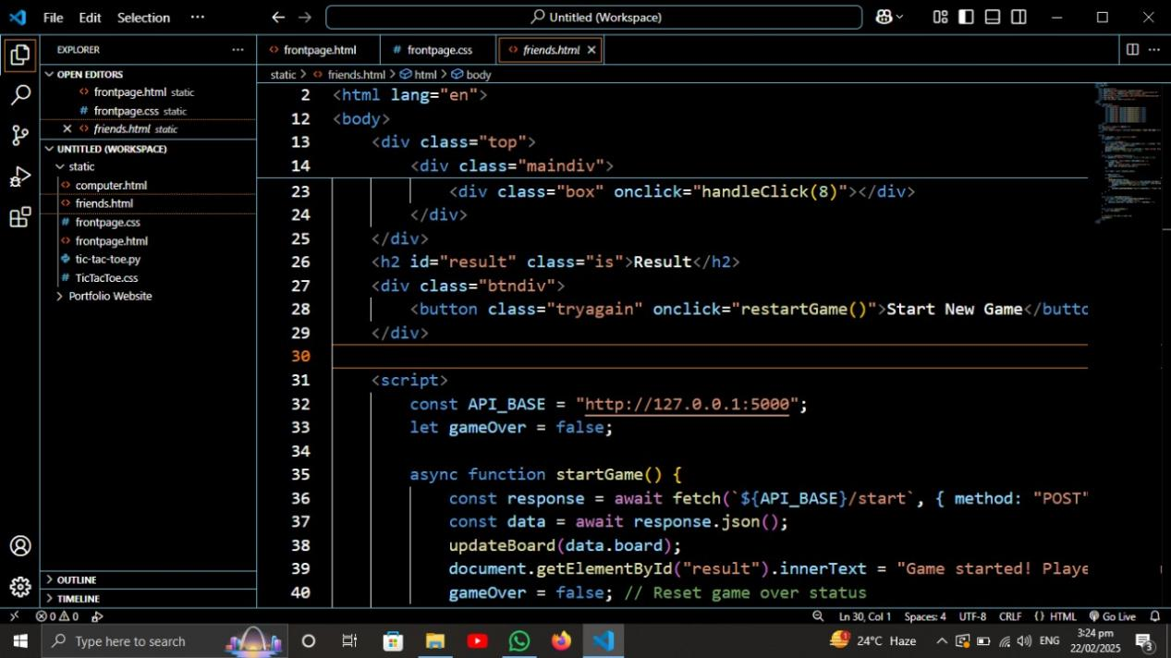

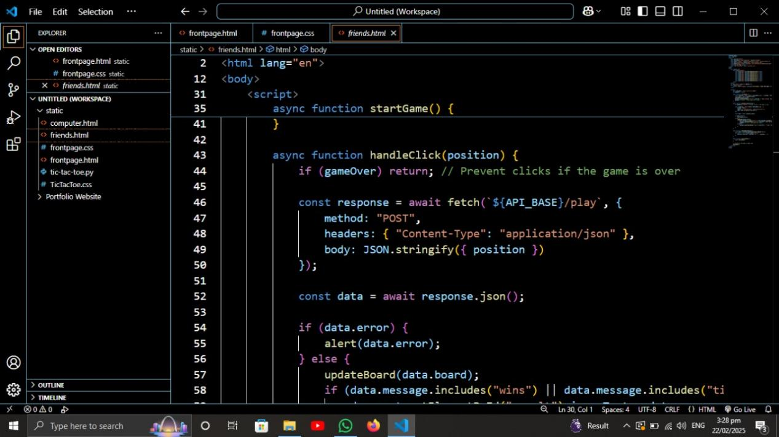

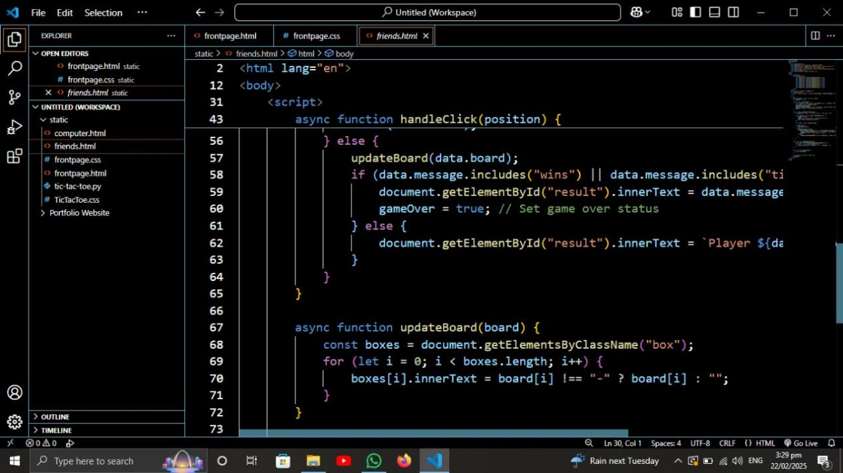

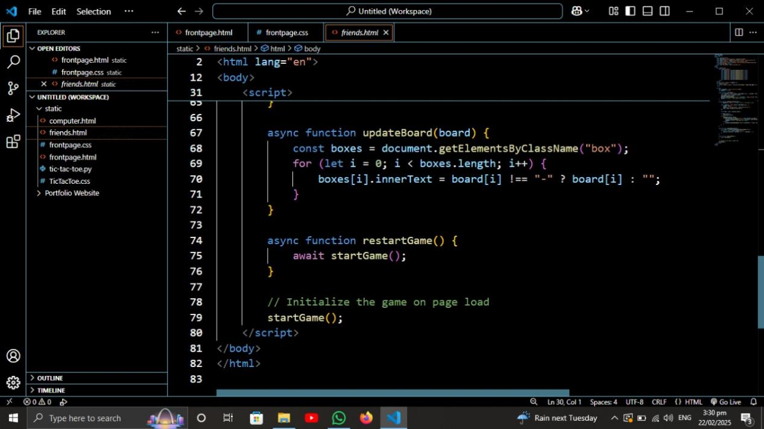

Play with computer HTML:

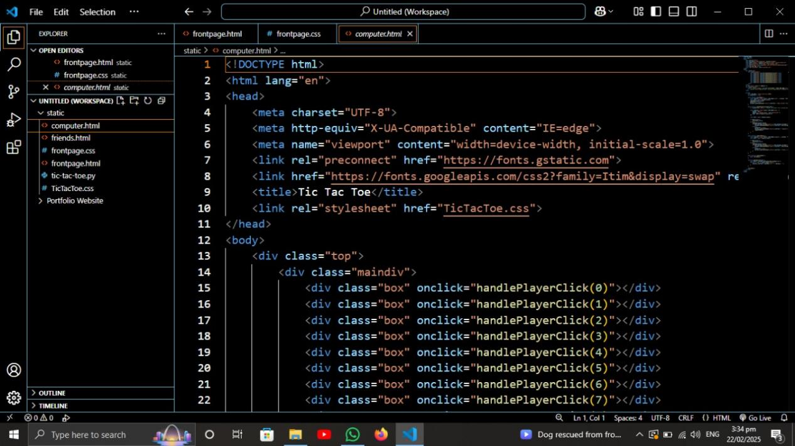

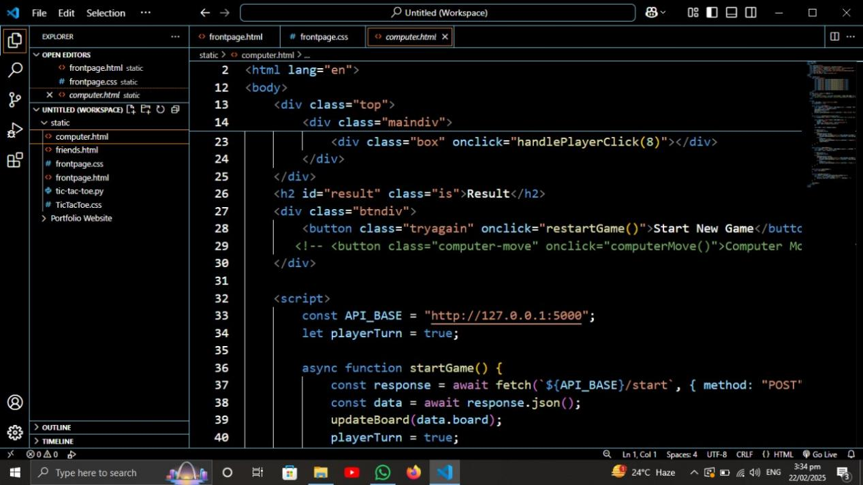

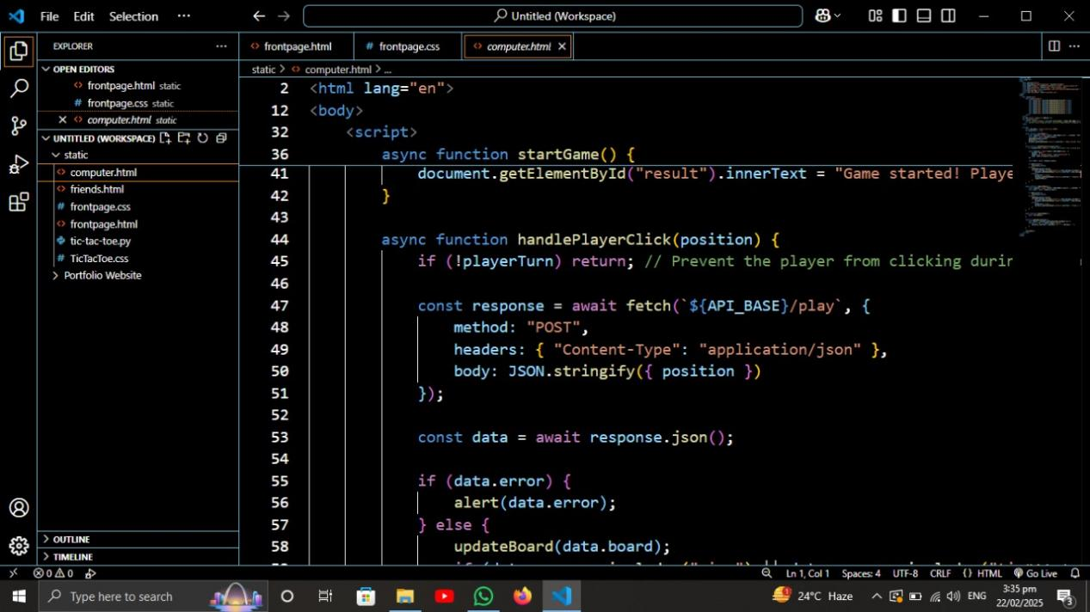

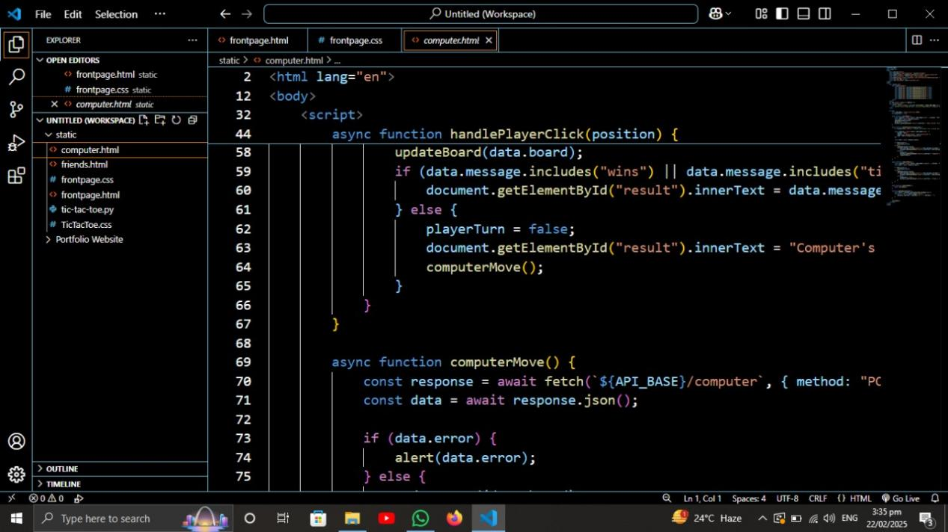

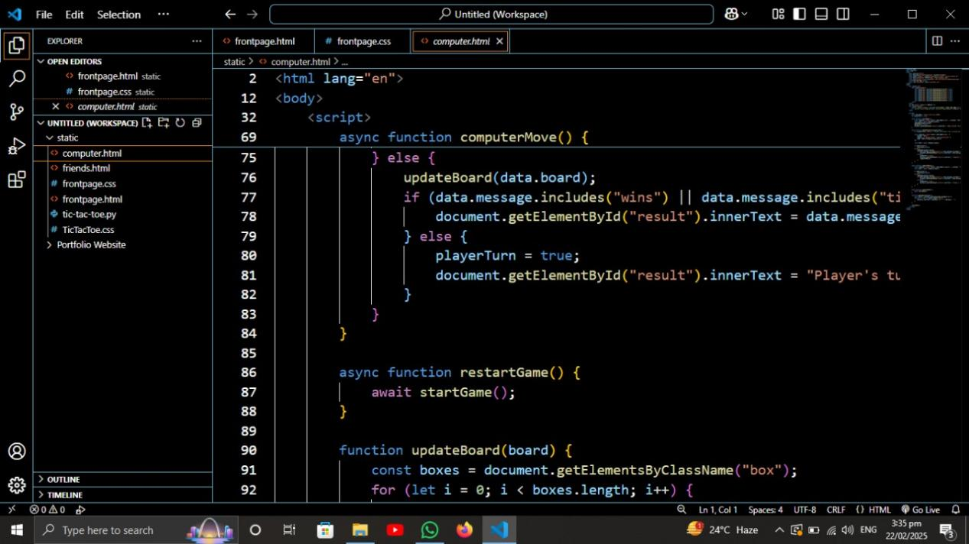

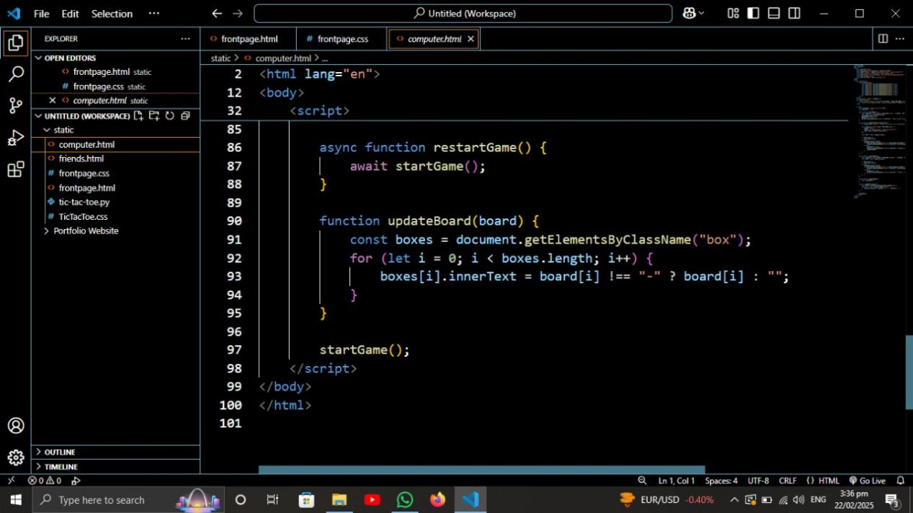

Play with friend and computer CSS:

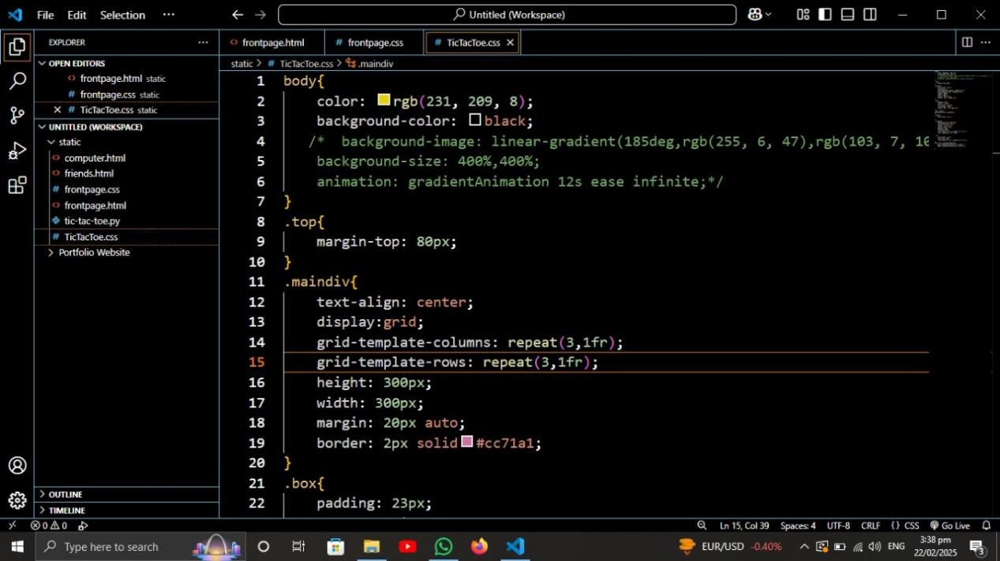
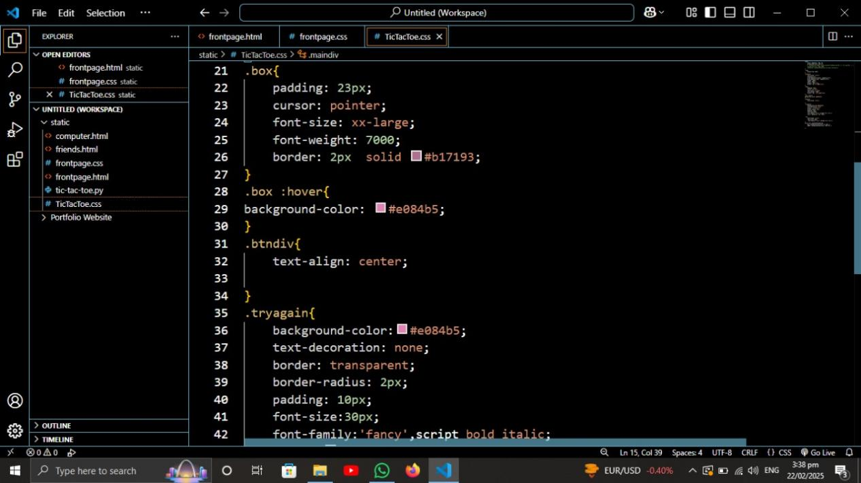

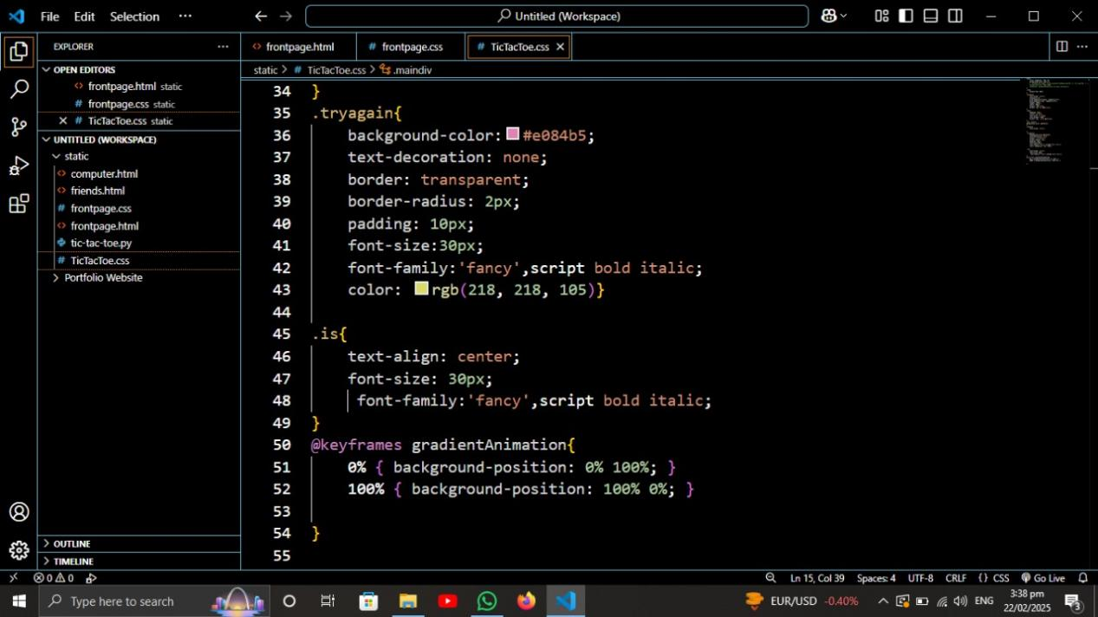

Backend code Screenshot:
The backend is developed using Python and Flask, handling the game logic, API requests, and responses. It ensures smooth interaction between the frontend and the game engine. The backend code includes:
- Flask routes to manage game actions.
- Game logic to determine turns, validate moves, and check for winners.
- API endpoints for communication between the frontend and backend.
Screenshots of the backend code are provided in this section, demonstrating the functionality that powers the game.

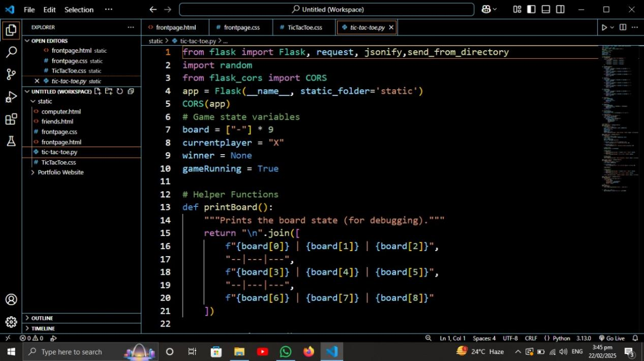

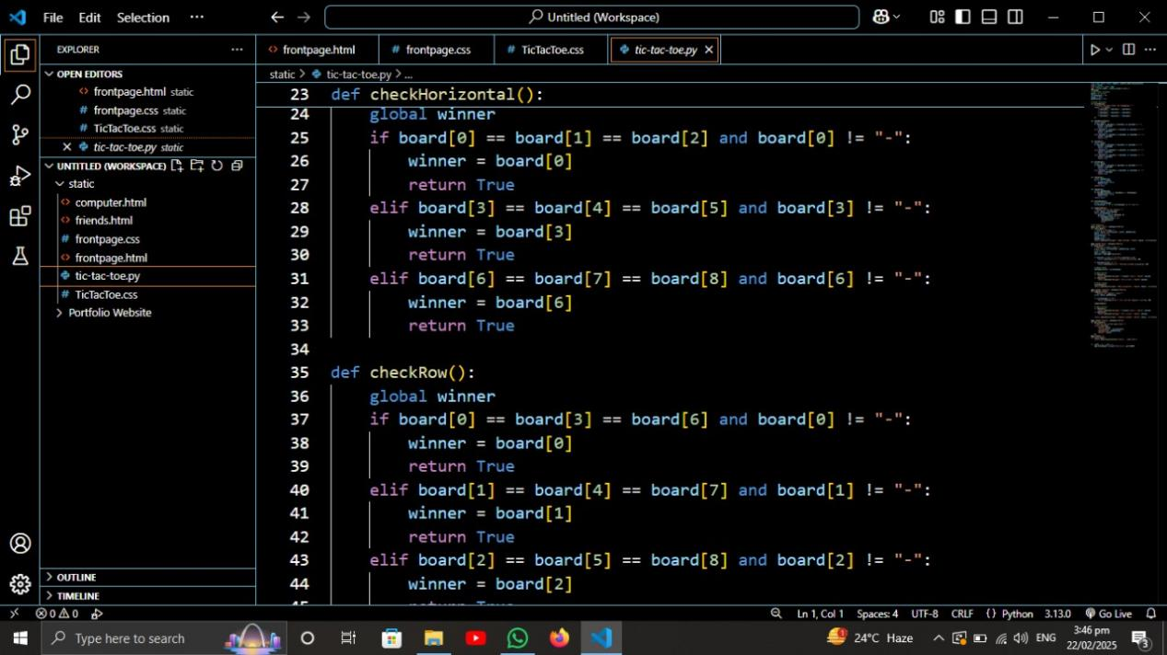

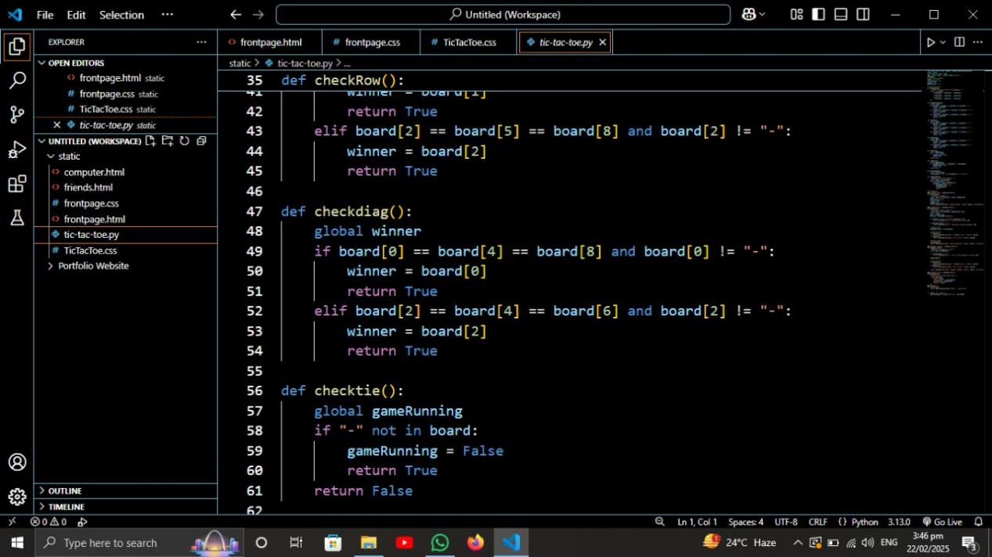

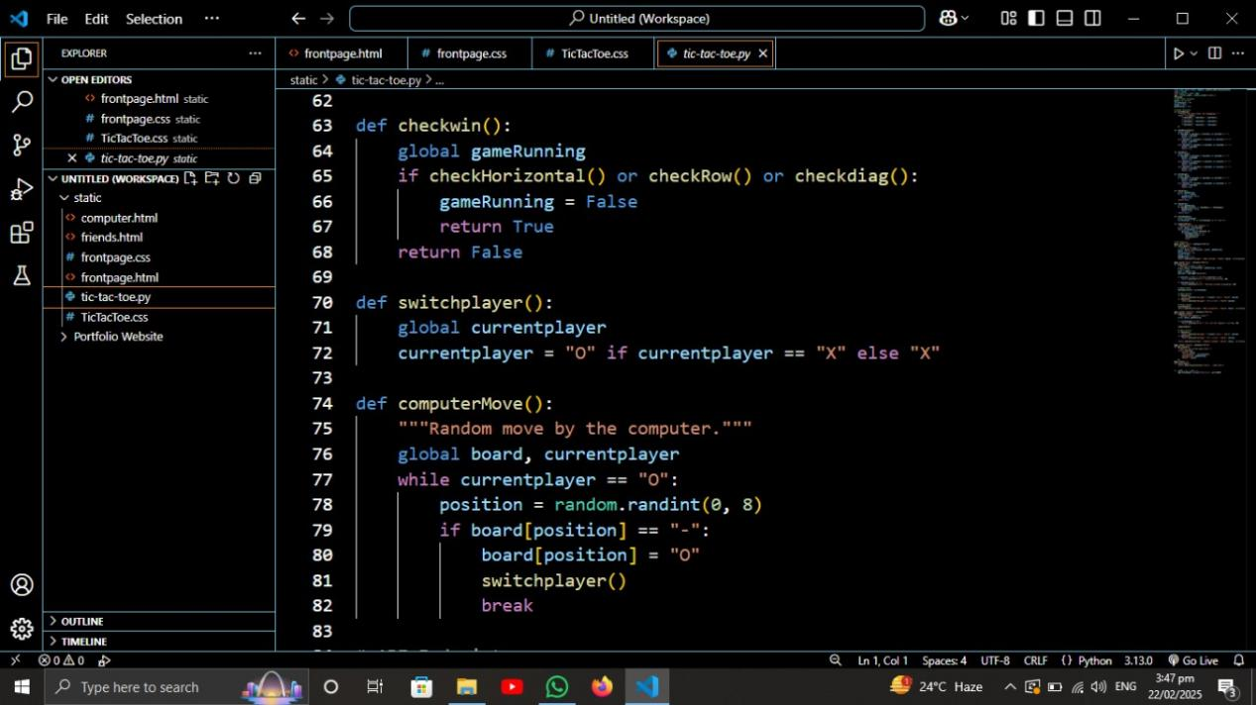

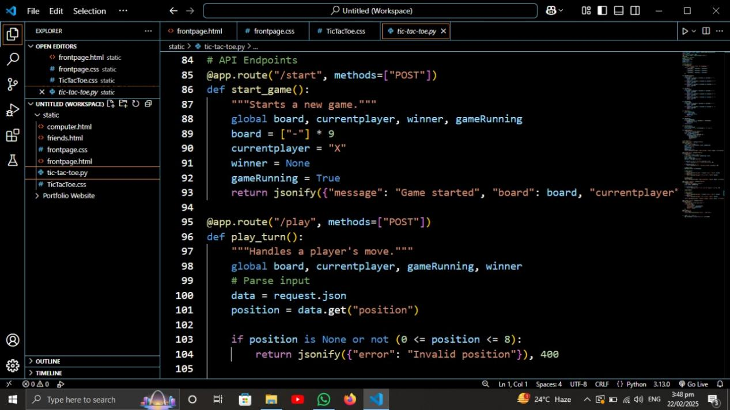

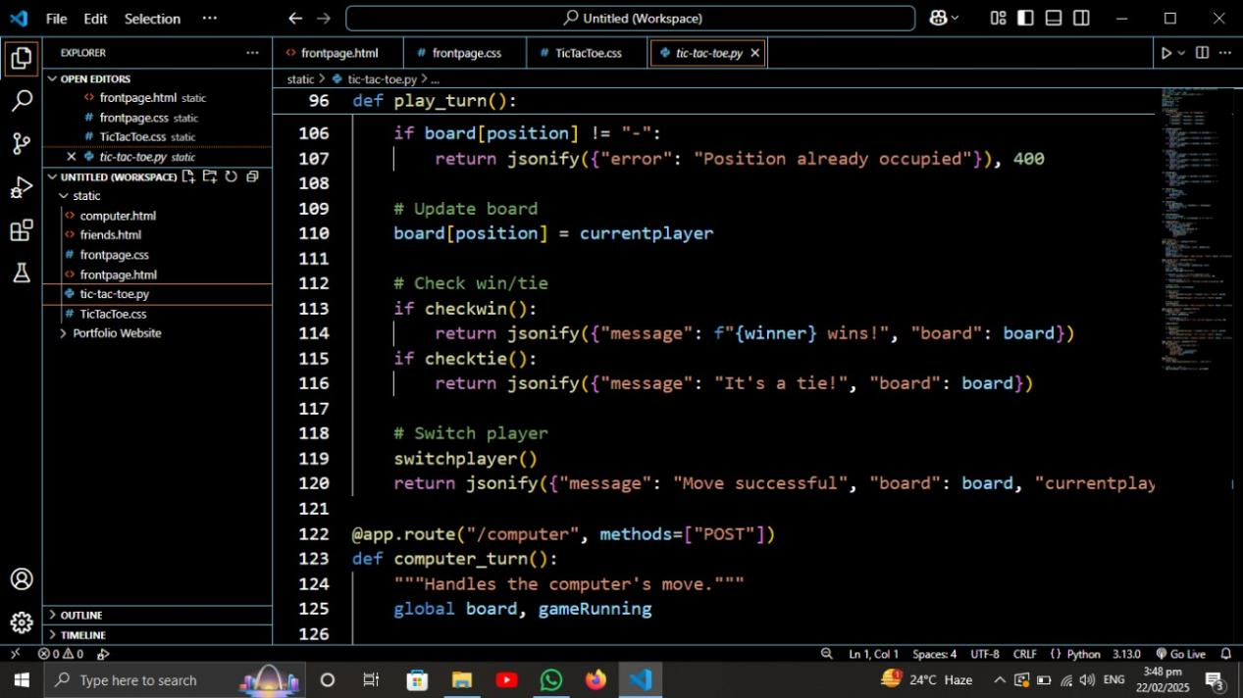

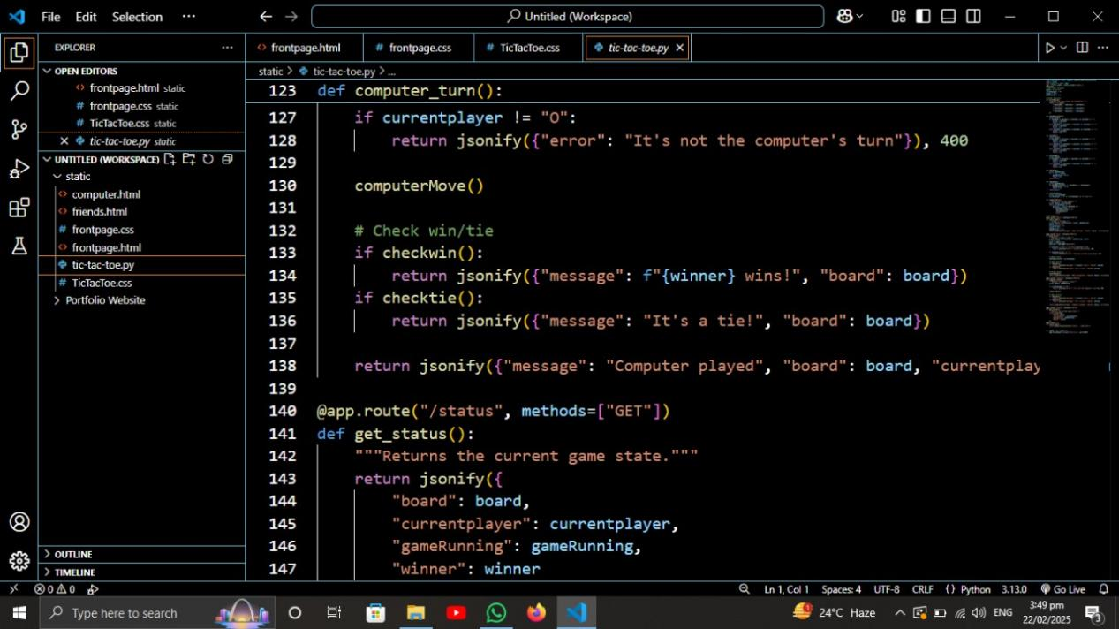

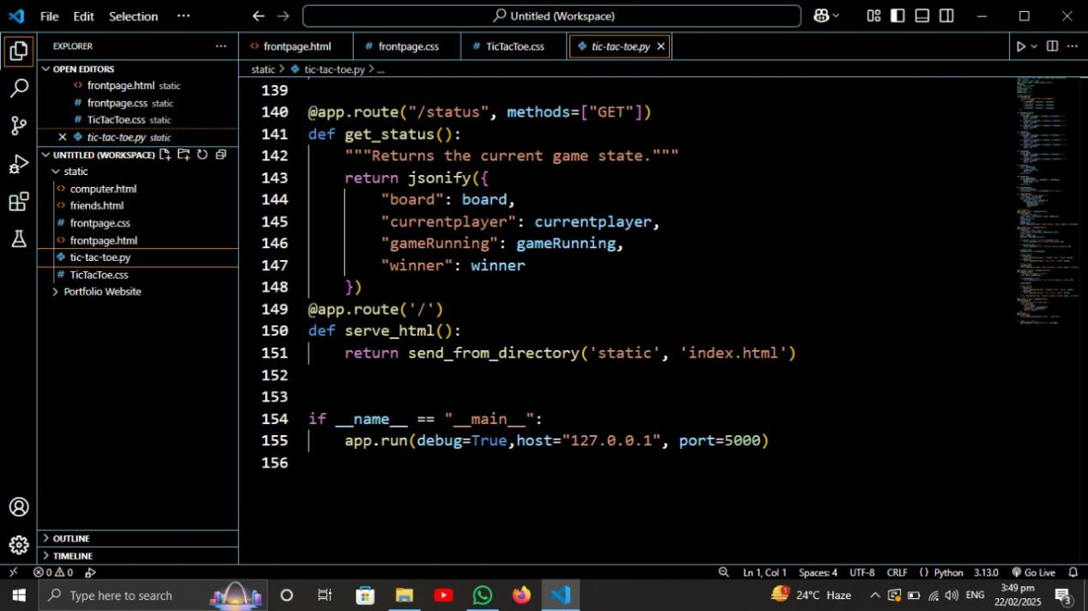

Project structure:

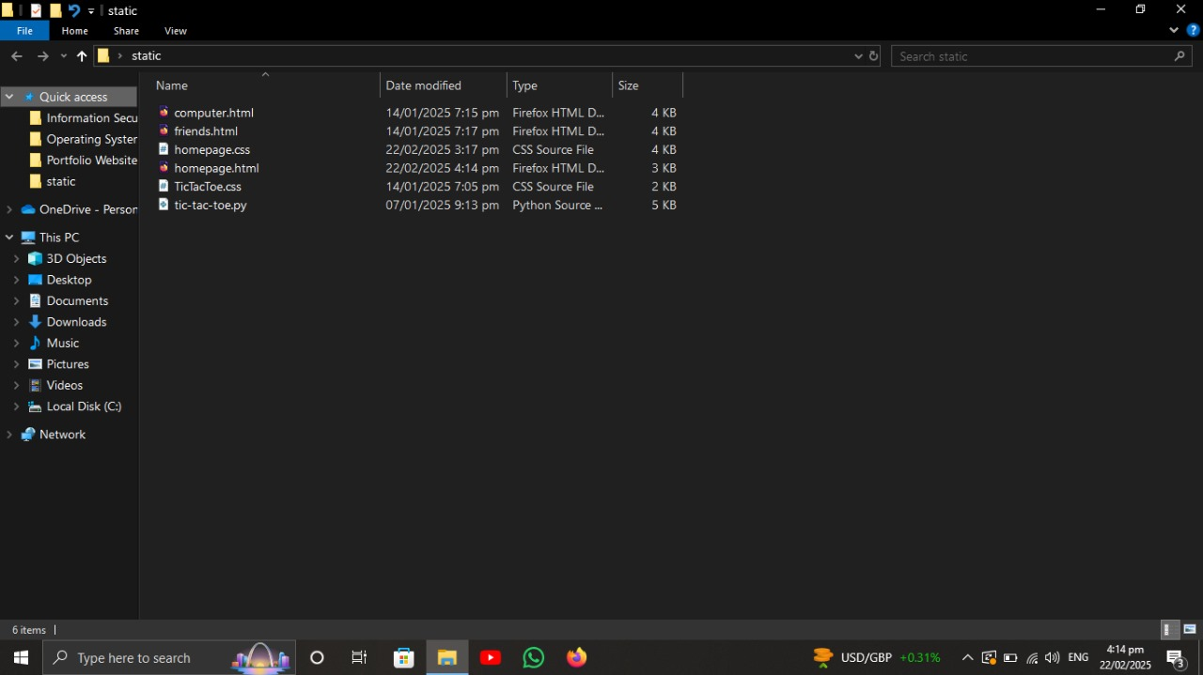

How to run:
- First run python file

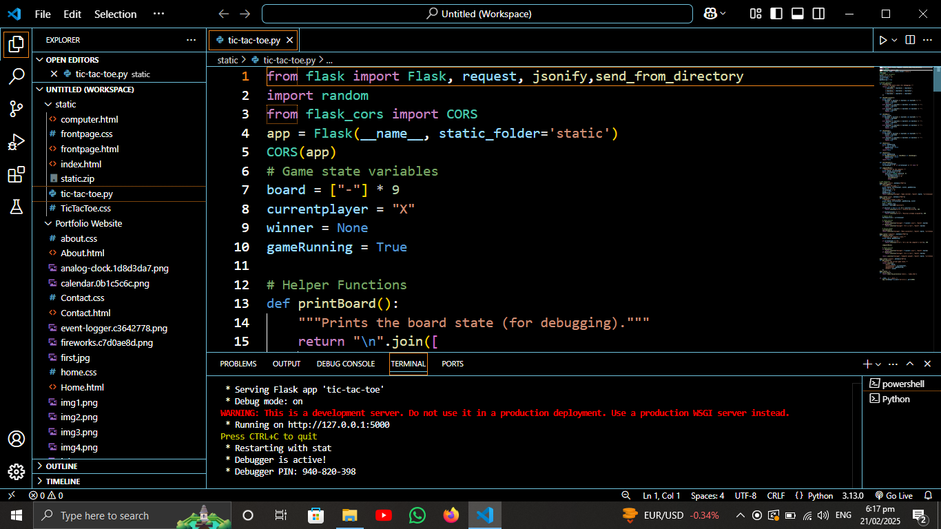

- Then in the folder run home page file

- This is the home page

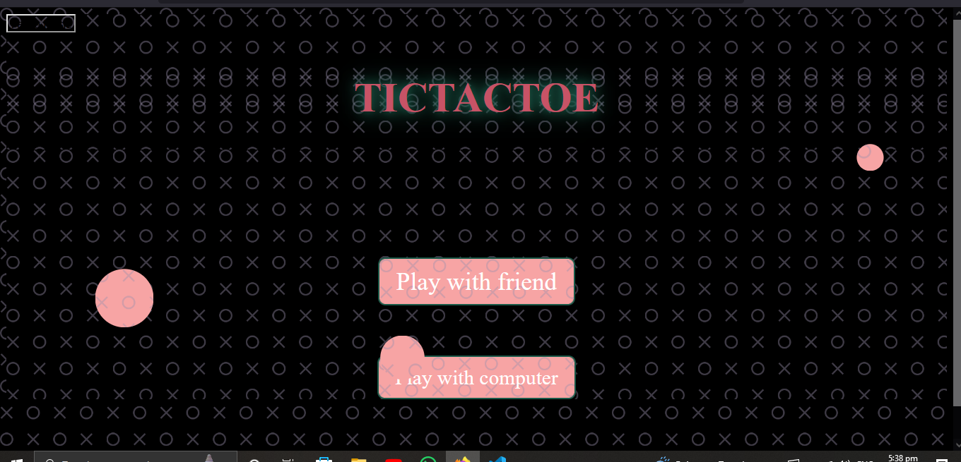

4. Play with friends

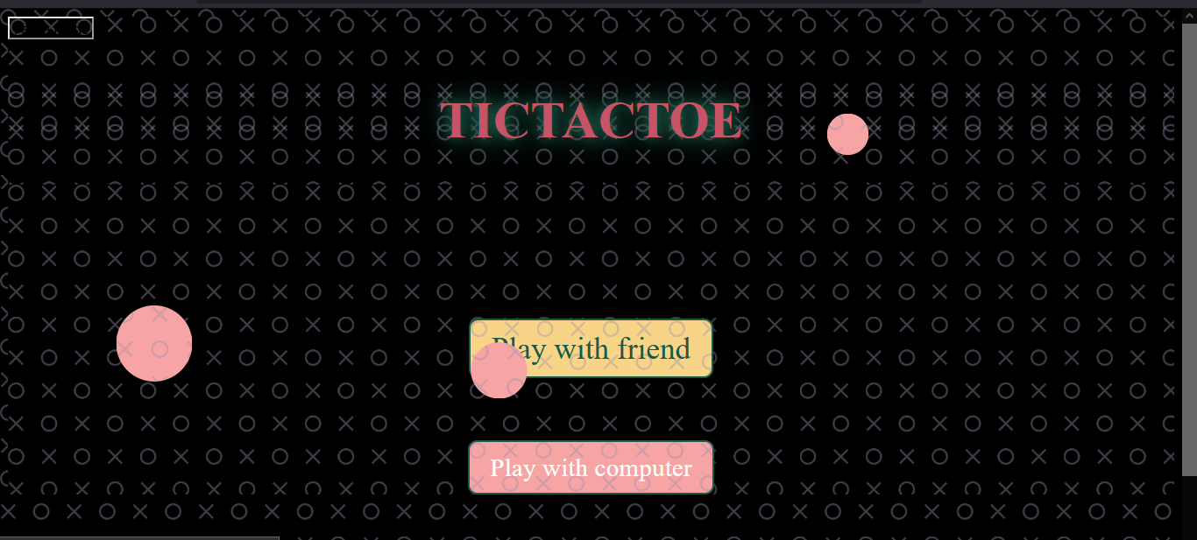

5. Player X's turn in play with friends

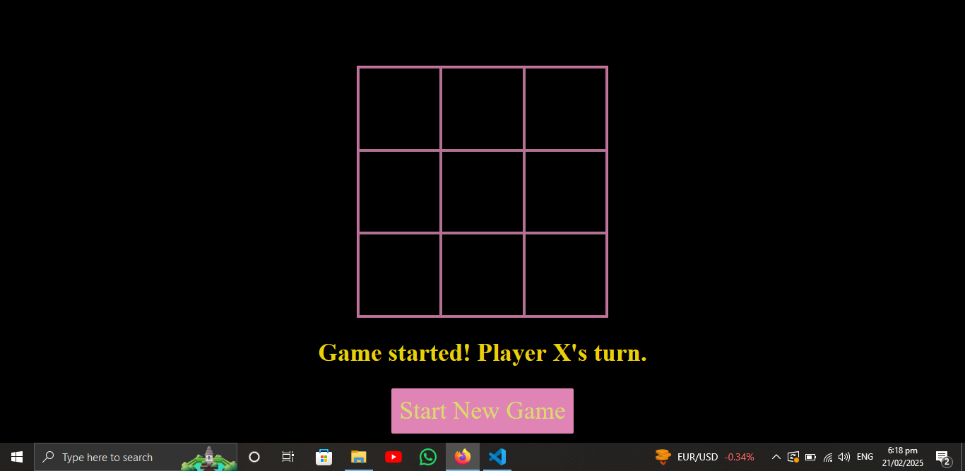

6. O's turn in play with friends:

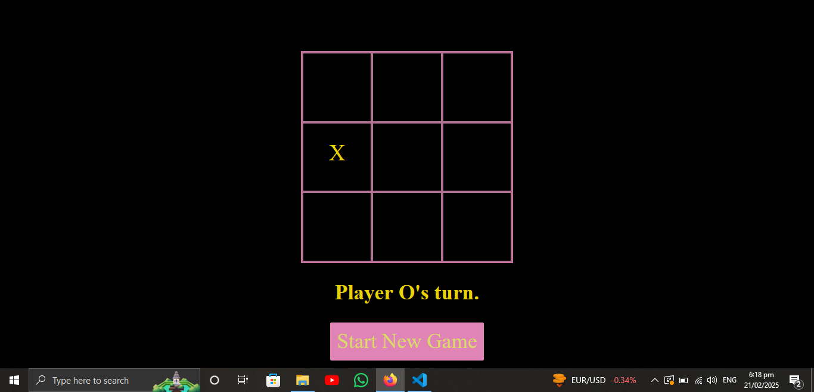

7. X wins in play with friends

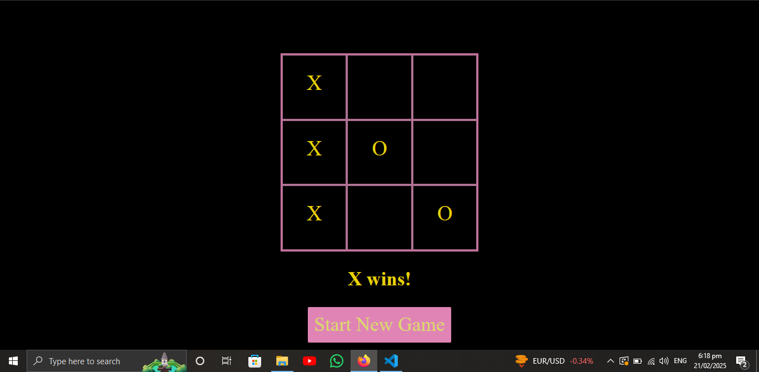

8. It's a tie

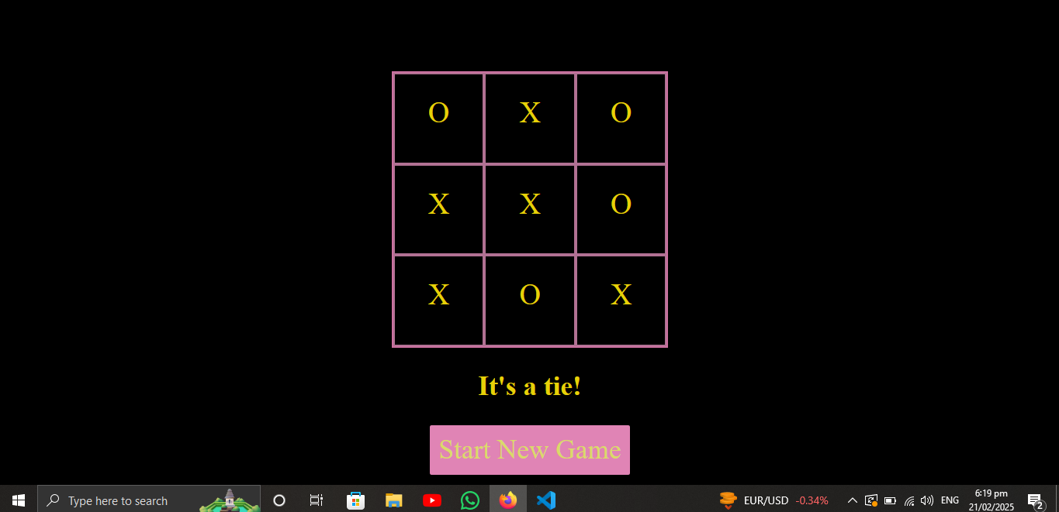

9. Play with computer

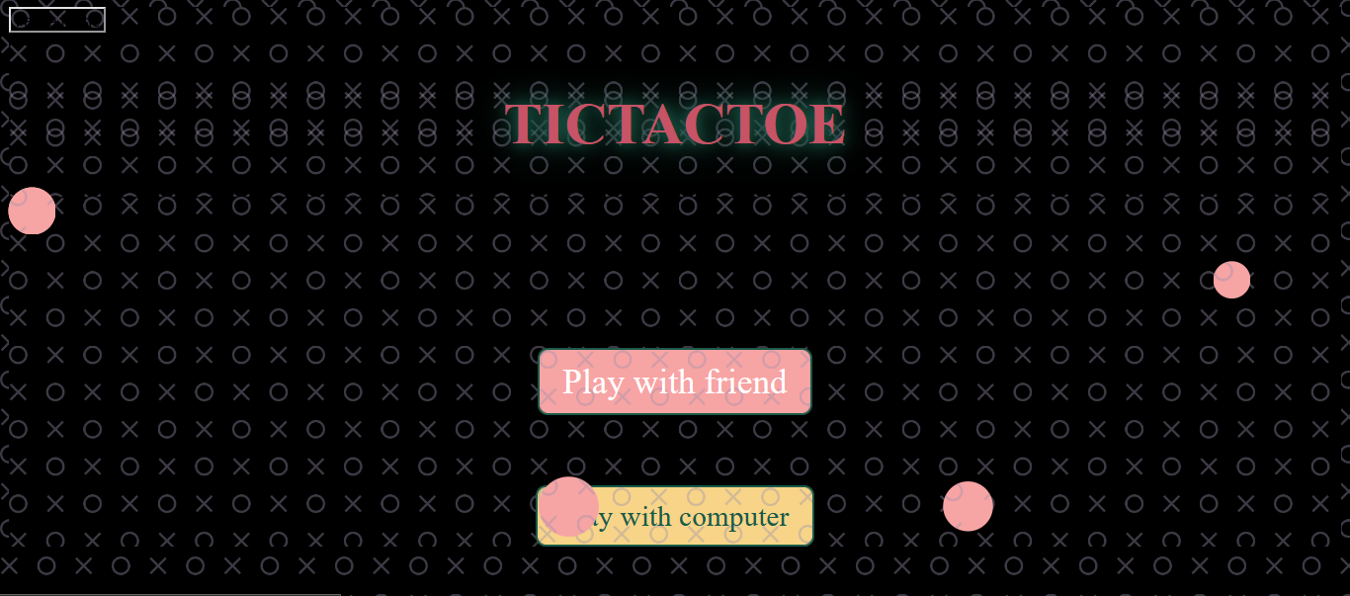

10. X's turn in play with computer

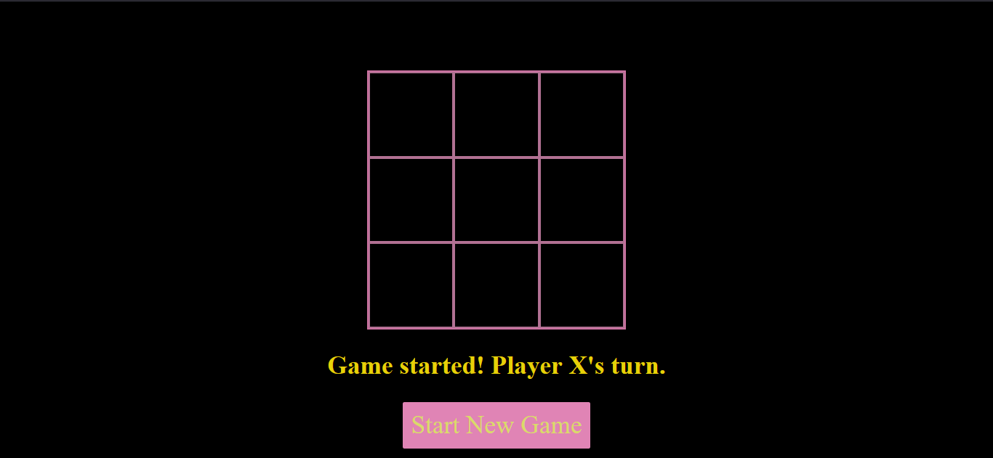

11. Computer plays

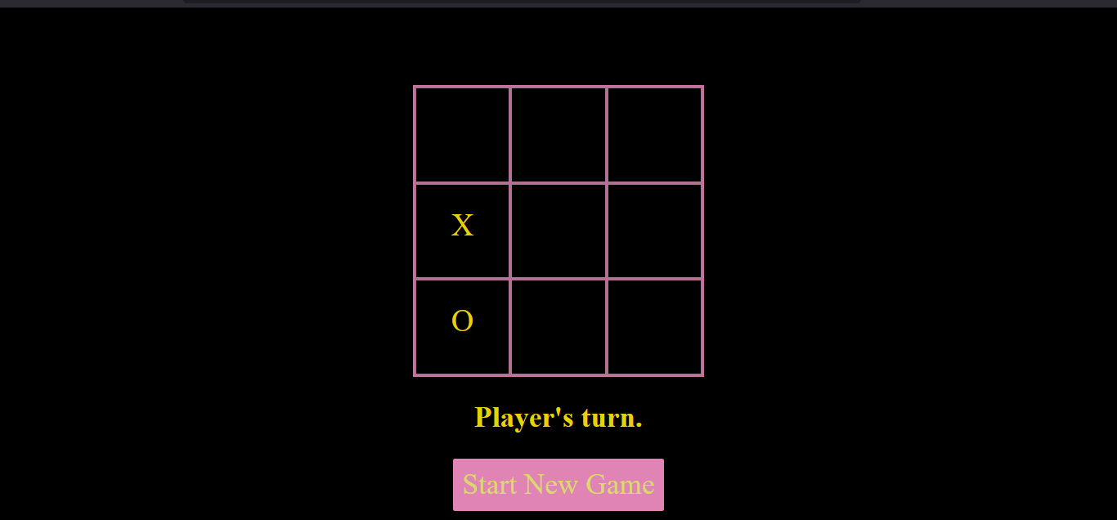

12. X wins in play with computer
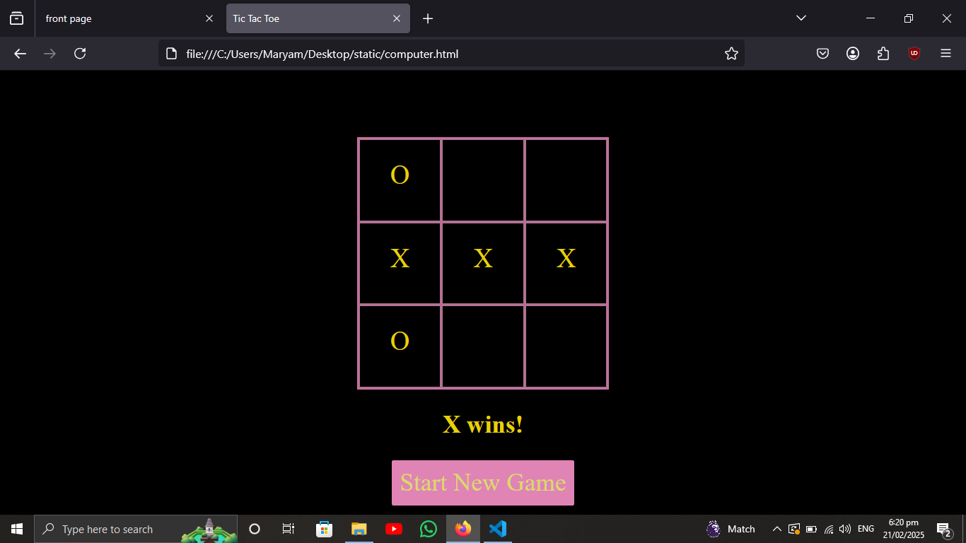

Conclusion:

This document contains the source code screenshots of the Tic-Tac-Toe project. The project was implemented using HTML, CSS, and Python Flask for backend functionality.

